Topological Sorting

Topological sorting for Directed Acyclic Graph (DAG) is a linear ordering of vertices such that for every directed edge u v, vertex u comes before v in the ordering. Topological Sorting for a graph is not possible if the graph is not a DAG.
For example, a topological sorting of the following graph is “5 4 2 3 1 0”. There can be more than one topological sorting for a graph. For example, another topological sorting of the following graph is “4 5 2 3 1 0”. The first vertex in topological sorting is always a vertex with in-degree as 0 (a vertex with no incoming edges).
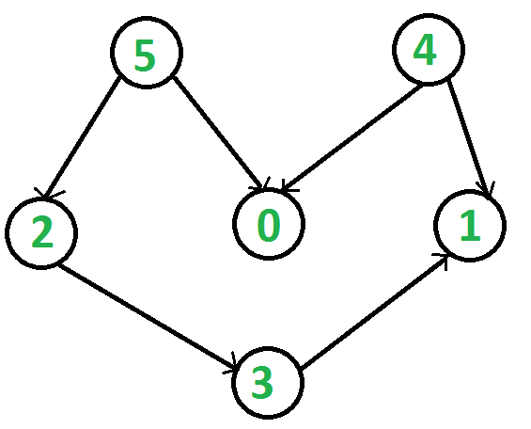
Topological Sorting vs Depth First Traversal (DFS):
In DFS, we print a vertex and then recursively call DFS for its adjacent vertices. In topological sorting, we need to print a vertex before its adjacent vertices. For example, in the given graph, the vertex ‘5’ should be printed before vertex ‘0’, but unlike DFS, the vertex ‘4’ should also be printed before vertex ‘0’. So Topological sorting is different from DFS. For example, a DFS of the shown graph is “5 2 3 1 0 4”, but it is not a topological sorting.
Algorithm to find Topological Sorting:
We recommend to first see the implementation of DFS. We can modify DFS to find Topological Sorting of a graph. In DFS, we start from a vertex, we first print it and then recursively call DFS for its adjacent vertices. In topological sorting, we use a temporary stack. We don’t print the vertex immediately, we first recursively call topological sorting for all its adjacent vertices, then push it to a stack. Finally, print contents of the stack. Note that a vertex is pushed to stack only when all of its adjacent vertices (and their adjacent vertices and so on) are already in the stack.
Below image is an illustration of the above approach:
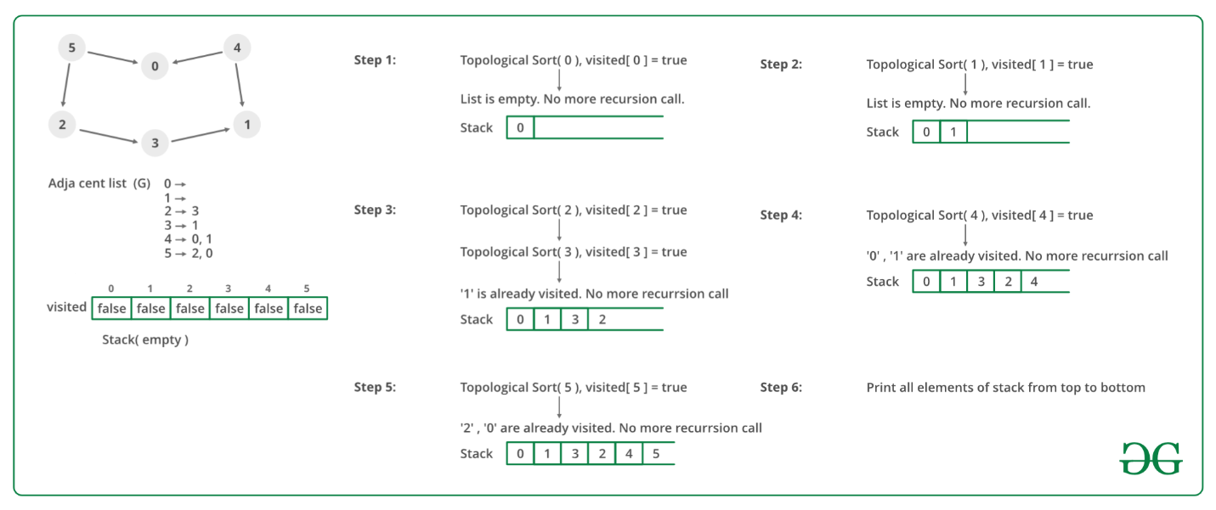

Kahn’s algorithm for Topological Sorting
Topological sorting for Directed Acyclic Graph (DAG) is a linear ordering of vertices such that for every directed edge uv, vertex u comes before v in the ordering. Topological Sorting for a graph is not possible if the graph is not a DAG.
For example, a topological sorting of the following graph is “5 4 2 3 1 0?. There can be more than one topological sorting for a graph. For example, another topological sorting of the following graph is “4 5 2 0 3 1″. The first vertex in topological sorting is always a vertex with in-degree as 0 (a vertex with no in-coming edges).
Let’s look at few examples with proper explanation,
Example:
Input:
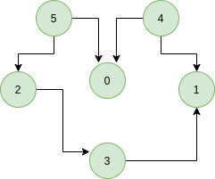
Output: 5 4 2 3 1 0
Explanation: The topological sorting of a DAG is done in a order such that for every directed edge uv, vertex u comes before v in the ordering. 5 has no incoming edge. 4 has no incoming edge, 2 and 0 have incoming edge from 4 and 5 and 1 is placed at last.
Input:
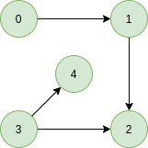
Output: 0 3 4 1 2
Explanation: 0 and 3 have no incoming edge, 4 and 1 has incoming edge from 0 and 3. 2 is placed at last.

Recommended: Please solve it on “PRACTICE” first, before moving on to the solution.
A DFS based solution to find a topological sort has already been discussed.
Solution: In this article we will see another way to find the linear ordering of vertices in a directed acyclic graph (DAG). The approach is based on the below fact:
A DAG G has at least one vertex with in-degree 0 and one vertex with out-degree 0.
Proof: There’s a simple proof to the above fact is that a DAG does not contain a cycle which means that all paths will be of finite length. Now let S be the longest path from u(source) to v(destination). Since S is the longest path there can be no incoming edge to u and no outgoing edge from v, if this situation had occurred then S would not have been the longest path
=> indegree(u) = 0 and outdegree(v) = 0
Algorithm: Steps involved in finding the topological ordering of a DAG:
Step-1: Compute in-degree (number of incoming edges) for each of the vertex present in the DAG and initialize the count of visited nodes as 0.
Step-2: Pick all the vertices with in-degree as 0 and add them into a queue (Enqueue operation)
Step-3: Remove a vertex from the queue (Dequeue operation) and then.
- Increment count of visited nodes by 1.
- Decrease in-degree by 1 for all its neighbouring nodes.
- If in-degree of a neighbouring nodes is reduced to zero, then add it to the queue.
Step 4: Repeat Step 3 until the queue is empty.
Step 5: If count of visited nodes is not equal to the number of nodes in the graph then the topological sort is not possible for the given graph.
How to find in-degree of each node?
There are 2 ways to calculate in-degree of every vertex:
- Take an in-degree array which will keep track of
Traverse the array of edges and simply increase the counter of the destination node by 1.
for each node in Nodes
indegree[node] = 0;
for each edge(src, dest) in Edges
indegree[dest]++
- Time Complexity: O(V+E)
- Traverse the list for every node and then increment the in-degree of all the nodes connected to it by 1.
for each node in Nodes
If (list[node].size()!=0) then
for each dest in list
indegree[dest]++;
- Time Complexity: The outer for loop will be executed V number of times and the inner for loop will be executed E number of times, Thus overall time complexity is O(V+E).
The overall time complexity of the algorithm is O(V+E)

Rough work
Methode 1:
Step1: it’s a Directed acyclic graph
Set={4,0}
Set{4,1}
Set{4}
Set={5,2,3}
Set={5,2}
Set={5}
Stack=
0 | 1 | 4 | 3 | 2 | 5
LIFO
Topological sorted order= 5,2,3,4,1,0

Methode 2: Kahn’s algorithm for Topological Sorting

5=0
4=0
0,1=2
2,3=1
Queue= FIFO
5 | 4 | 0 | 2 | 3 | 1

4=0, 0=1, 2=0, 3=1,1=2
0=0, 1=1, 3,1, 2=0
2=0, 3=1,1=1
3=0,1=1
1=0
Topological order=5,4,0,2,3,1

